1. Put the verbs in the brackets into PRESENT CONTINUOUS:
- My mom ________________________________ (eat) a sandwich.
- You __________________________________ (not read) a book right now.
- We ______________________________ (take) a test now.
- Shhhhh! I ____________________________ (watch) TV!
- ______ they _________________ (cook) dinner?
- Look! It _____________________ (snow)!
- The sun __________________________ (not shine) today.
- Danny and Mandy _____________________ (ride) a bike in the park.
- ______ you _____________ (meet) Joe and Mary tonight?

- Put the verbs in brackets in the present continuous tense.
Examples: She is cooking something delicious. Can you smell? (cook)
He is not working at the moment. (not work)
Listen! Is somebody coming? (come)

- I'm at the station now. I ……………………………………. (wait) for the train.
- The train ……………………………….. (come), look!
- Susan is in the kitchen. She …………………………………. (get) the luch ready.
- What …………………. you ……………………….. (do) now?
- Excuse me, can you help me? I …………………………………. (look) for a post office.
- We ………………………………… (prepare) a party at the moment, but it ……………………………………… (not take) us away from our duties.
- ………….. Vicky ………………………….. (wear) her blue dress today?

3. Make sentences in Present Continuous.
1. A bird/fly ___________________________________________________________
2. He/read/a book. ___________________________________________________________
3. We/play/football. _________________________________________________________
4. Marko and Igor/go/to school. ________________________________________________
5. You/climb/a tree. __________________________________________________________
6. The sun/shine. ____________________________________________________________
7. Mia/dance/with Mark. ______________________________________________________

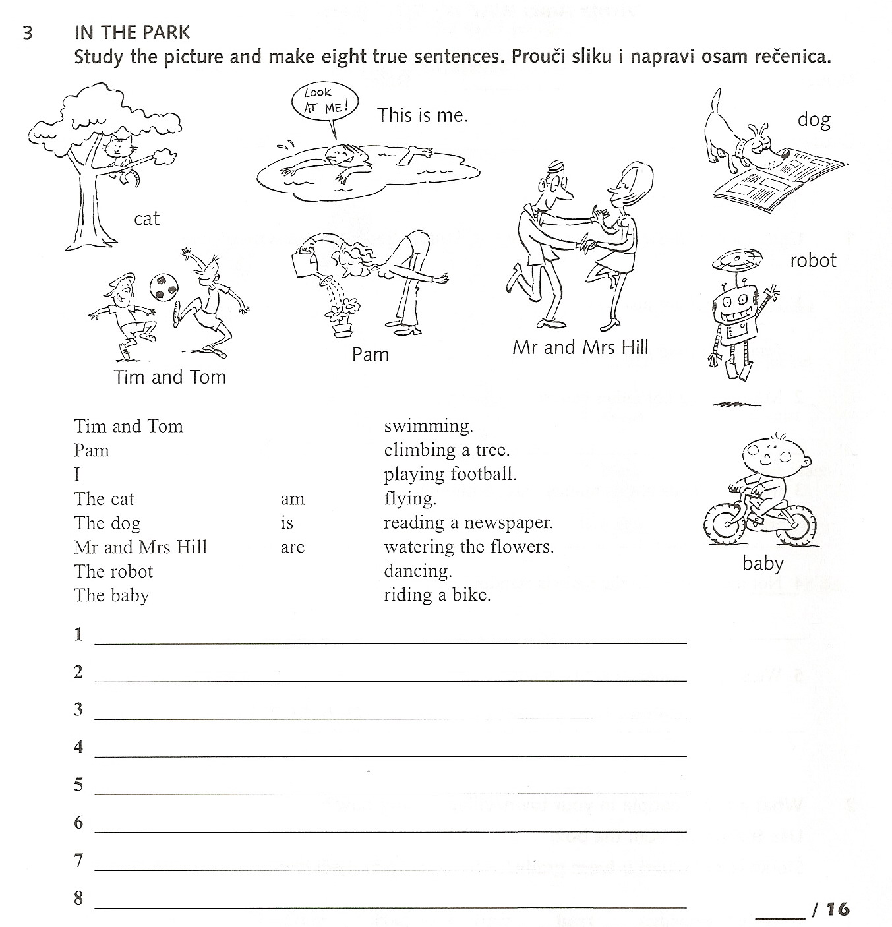

- What is your family doing? Use words probably, maybe, perhaps, I think. Što radi tvoja obitelj, koristi riječi probably, maybe, perhaps, I think.

